https://windowsreport.com/run-windows-xp-windows-10/:

Run Windows XP in Windows 10 with VirtualXP
 | By: Ivan Jenic ▪ October 11, 2018  windows 10, windows XP

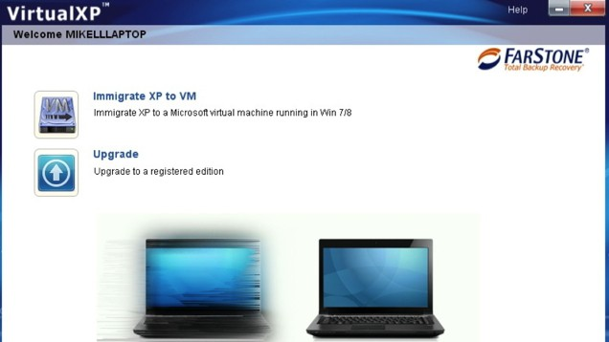

A lot of people still use Windows XP, although it’s almost sixteen years old. On the other hand, a lot of people are participating in Microsoft’s Insider Program and using Windows 10 Technical Preview builds. There are also millions of computer users who rely on the stable versions of Windows 10 worldwide.
So, if you want to try the new Windows 10, but don’t want to give up your trusted Windows XP, you can try to run your Windows XP within Windows 10 with a little program called VirtualXP.

Contents
Run Windows XP on Windows 10 2
Download VirtualXP for Windows 10 2
Windows XP mode on Windows 10 2
Related Guides to Check out: 2

I know many of you would say that virtual machine is the only right choice for running one Windows operating system within another. And you’re probably right, but installing you second system on the virtual machine means that you have to install a fresh, clean copy of Windows, and then install all third-party programs afterwards.

Run Windows XP on Windows 10
But with VirtualXP you can keep all the programs you installed on your old XP and transfer them to the newer version of Windows.
VirtualXP simply converts your current Windows XP system and all programs installed on it to the Microsoft virtual image. Once the conversion is finished, you can open it in Windows 10 and access your XP system, files and programs just like you do with the virtual machine.
One of the main reasons people choose not to install Windows 10 Technical Preview on their computers are program compatibility issues. A lot of older programs can’t even be installed on Windows 10, and people who use them simply choose to stick with their current operating system.
With VirtualXP you’ll be able to try all exciting features of Windows 10 and run all the programs you used in Windows XP at the same time.
We hope that Microsoft will fix the compatibility issues with older programs in the future, but until that happens (if it ever happens), you can use VirtualXP as an alternative solution for running programs compatible with Windows XP in Windows 10.
- RELATED: The ultimate list of the best Windows XP software to use in 2018

Download VirtualXP for Windows 10
You can download VirtualXP from Farstone’s website for free.
UPDATE: Since this post was initially published, VirtualXP is no longer available for download from FarStone. However, we found an alternative tool that you can use instead.

Windows XP mode on Windows 10
Alternatively, you can download and install the Windows XP Mode directly from Microsoft’s official website. With the help of this tool, you can easily run Windows XP specific programs on your Windows 10 computer. Of course, this tool is not the same as VirtualXP.
More specifically, with the Windows XP Mode, you still need to install Windows XP on your machine. However, Farstone’s VirtualXP tool allowed you to simply migrate your Windows XP OS and apps to your virtual disk. And now you know.

Related Guides to Check out:
- Steam ends support for Windows XP and Vista in 2019
- 5 best antivirus software for Windows XP Service Pack 3 in 2018
- 5 best VPNs for Windows XP in 2018
Editor’s Note: This post was originally published in May 2015 and has been since updated for freshness, and accuracy.

